What makes us think it through? Experimental evidence for a link between confidence and deliberation
Purcell^{1,*}, Z. A., Desender², K., & De Neys¹, W.

1. LaPsyDÉ, Université Paris Cité, CNRS, F-75005 Paris, France
2. Brain and Cognition, KU Leuven, Belgium
* Corresponding author: purcell.z.a@gmail.com

Acknowledgements: This research was supported by the Agence National de France [ANR-23-AERC-0006] awarded to Z. A. Purcell. KD acknowledges support from the Research Foundation Flanders, 743 Belgium (FWO-Vlaanderen No. G0B0521N; awarded to K. Desender).
Abstract
Deliberative, effortful thinking supports better reasoning about science, politics, and everyday problems, but what drives its engagement remains unclear. One possibility is that low confidence acts as a trigger for deliberation. Across four preregistered experiments (N ≈ 1,200), we provide a causal test of this hypothesis. Participants received manipulated feedback about their performance on classic reasoning problems (bat-and-ball or base-rate tasks) presented in standard, single response formats (Studies 1-2) or two-response formats in which participants give both a timed and an untimed response for each problem (Studies 3-4). In the single-response studies, negative feedback reliably reduced confidence and increased response times compared to control and positive feedback. In the two-response studies, negative feedback again reduced confidence and lengthened response times. Critically, it also increased the likelihood of revising initial answers and prolonged second-stage response times—hallmarks of deliberation. Moreover, feedback-affected confidence, measured immediately after initial, timed responses and before deliberation was possible, predicted both revisions and extended second-stage processing. Together, these findings offer robust causal evidence that confidence regulates the deployment of deliberative reasoning and clarify what makes us “think it through”.

Deliberative thinking—our ability to reason in a controlled, analytic, and effortful way—is often linked to positive outcomes, such as better logical reasoning and forming more accurate beliefs about science and politics (Bago et al., 2020; Howarth et al., 2016; Kahneman, 2012; Pennycook, 2023). Despite its benefits, deliberative thinking is not always deployed adaptively. People sometimes engage too little, such as when evaluating misinformation (Bago et al., 2020), or too much, as seen in anxious rumination or indecision (McLaughlin & Nolen-Hoeksema, 2011). These contemporary observations have renewed the long-standing, fundamental interest in understanding what regulates the engagement of deliberate processes, and how such engagement might be modulated.
Across fields from neuroscience to philosophy, confidence has been identified as a potential regulator of deliberation (De Neys, 2022; Desender et al., 2018; Duncan, 2010; Hohwy, 2020). Several models, though differing in emphasis, converge on the idea that low confidence (stemming from high cognitive uncertainty) drives increased cognitive control and effort. Predictive processing and free energy accounts frame uncertainty reduction not just as a trigger for more deliberation and adaptive behaviour but as the fundamental, primary role of the mind (Clark, 2013; Friston, 2010; Hohwy, 2013, 2020). Neurocognitive models, such as the multiple-demand network and global workspace theories, propose that uncertainty grants access to distant cognitive resources and conscious processing (Dehaene & Naccache, 2001; Duncan, 2010; Mashour et al., 2020; Woolgar et al., 2018). Metareasoning frameworks further highlight the interaction between cues like the ease with which a response comes to mind, motivation, and task demands, in regulating time investment (Ackerman, 2014; Ackerman & Thompson, 2017; Thompson et al., 2011).
Emphasising the role of confidence in high-level reasoning, the prominent dual-process theories characterise thinking as the interaction between a fast, intuitive system and a slower, deliberative one (Evans & Stanovich, 2013; Kahneman, 2012). While early accounts focused on this dichotomy and its subjective and behavioural distinctions, more recent models emphasise how the systems interact and their dynamic regulation through metacognition. They specify that confidence reflects the relative strength of competing intuitions: when one response is clearly dominant, confidence is high and deliberation is unlikely to be triggered; when multiple intuitions conflict, confidence is low, prompting analytic engagement (Bago & De Neys, 2017; De Neys, 2022; De Neys & Pennycook, 2019; Pennycook et al., 2015; Thompson et al., 2011). From this perspective, confidence functions as a regulatory signal that guides whether intuitive or deliberative processing is engaged. Rather than being a passive byproduct of reasoning, confidence is positioned as a central mechanism in the control of high-level cognition.
Support for the confidence–deliberation hypothesis comes from consistent evidence of a negative association between confidence and response time across various reasoning tasks, including syllogistic, mathematical, and conditional inference (e.g., Bago & De Neys, 2017, 2019; Purcell et al., 2022; Thompson et al., 2013). The strongest evidence arises from studies employing the two-response paradigm (Thompson et al., 2011), in which participants respond to each problem twice: first under time pressure, providing their initial, intuitive answer; and again without time constraints, allowing for reflection and revision. Confidence ratings are collected after both the first intuitive and after the second unconstrained response. This method enables a more direct—albeit conservative—index of deliberation via answer changes, in contrast to relying solely on longer response times, which may not necessarily reflect deeper cognitive engagement (Thompson et al., 2011). Findings consistently show that lower initial confidence predicts longer second-stage response times and an increased likelihood of revising one's answer—effects replicated across multiple reasoning domains and with different measures of metacognitive assessment (Bago & De Neys, 2017, 2019; Purcell et al., 2022; Thompson et al., 2013). Notably, these studies are correlational and therefore do not involve experimental manipulations of confidence. Thus, they provide preliminary but indirect support for the view that confidence modulates deliberative engagement.
To test whether confidence causally influences deliberation, it is necessary to experimentally manipulate confidence itself. Recent work drawing on training paradigms in debiasing and cognitive automation show some promise (Purcell et al., 2021; Boissin et al., 2021). For instance, Purcell, Wastell and Sweller (2022) demonstrated that feedback on “bat-and-ball” style reasoning problems (“A bat and a ball cost $1.10 together. The bat costs $1 more than the ball. How much does the ball cost?” The correct answer is 5 cents; however, the most common response is 10 cents; Frederick, 2005) systematically altered participants’ confidence, as measured by both subjective ratings and eye-tracking indices. Importantly, changes in confidence and accuracy emerged at different stages of training, suggesting that confidence is not merely a reflection of performance but can be independently modulated. Moreover, these confidence shifts predicted key markers of deliberation, including increased rates of answer revision and longer second-stage response times.
Relatedly, research in educational and diagnostic contexts provides converging evidence that feedback influences cognitive performance in part by shaping confidence, with downstream consequences for effort and deliberation. In both student and clinician populations, feedback has been shown to affect self-efficacy, calibration, and perceived task difficulty, which in turn influenced willingness to invest mental effort (Heijltjes et al., 2015; Kuhn et al., 2022; Staal et al., 2024; van Gog et al., 2024). For example, van Gog and colleagues (2024) found that fake negative feedback increased anticipated mental effort through reduced self-efficacy and heightened threat, irrespective of actual performance. Similarly, studies in medical education show that real feedback can improve confidence–accuracy calibration, especially when it includes explanatory information, although effects are sensitive to task difficulty and prior accuracy (Staal et al., 2024).
Although research across reasoning, decision-making, and education suggests that feedback can influence confidence and, in turn, cognitive engagement, existing studies face key limitations in establishing causality. Real feedback is confounded with actual performance, making it difficult to isolate the effects of confidence from learning or error correction. Moreover, confidence is often measured after reasoning, precluding strong claims about its regulatory role, and deliberation is typically inferred from coarse metrics such as response time. To address these issues, the current work employs fake feedback—a method previously validated in low-level perceptual decision-making (e.g., motion direction detection, Van Marcke et al., 2024; Van Marcke & Desender, 2025)—to experimentally manipulate confidence. Building on prior findings using real feedback in reasoning tasks and fake feedback in perceptual domains, we apply this technique to reasoning problems and, critically, test whether shifts in confidence causally influence deliberation.
STUDY OVERVIEW
To examine a causal effect of confidence on deliberation, we conducted four preregistered experiments with classic reasoning problems (bat and ball and base-rate task, Frederick, 2005; Kahneman, 2011) that have been ubiquitous in the study of deliberation in the reasoning field. These tasks always include both standard versions in which an intuitively cued “heuristic” response conflicts with the correct response and control, no-conflict versions in which this conflict was removed (see methods). These tasks are well-suited for examining deliberation as, for conflict problems, deliberation is known to boost accuracy whereas, for no-conflict problems, deliberation is not required (De Neys, 2006; Pennycook et al., 2015).
In Studies 1–2, we validated a feedback manipulation previously deployed in perceptual decision making for reasoning tasks by testing its effects on confidence and response time using single-response designs. In Studies 3–4, we employed two-response formats to test whether confidence causally predicts deliberation, indexed by second-stage response time and answer change. Within two-response paradigms, individuals can modify their initial answer at Response 2. A change at this stage is widely recognised in the literature as one of the most robust indicators of deliberation, even stronger than response time. Although some participants may engage in additional reflection without altering their answers, those who revise their response are particularly likely to have engaged in deeper cognitive processing; to change one’s mind typically requires one of the core deliberative functions, for example, control and inhibition of the initial response and generation and the use of working memory to generate a new response (De Neys, 2025; Thompson et al., 2011).
Sample sizes were based on prior work using these paradigms, with approximately 100 participants per condition (e.g., Bago et al., 2021; Bago & De Neys, 2017). All studies received ethical approval from the Comité d’Éthique de la Recherche, Université Paris Cité (00012024-67), and all analyses, sample sizes, and procedures were preregistered. Some changes were made to the registered random effects structures to account for issues with singularity/convergence—final model structures are clearly described below (https://osf.io/4pdct/?view_only=b81683b6965842e9845a3cadbc7c03a3).

Study 1: Bat and Ball problems– Single Response

Method
Participants. Three hundred US participants were recruited online via Prolific and paid £4 (149 females, mean age = 39.38, SD = 12.78 years). Participants were randomly allocated to one of three feedback conditions: negative, control, and positive. For all studies, all participants provided consent to participate and those in the positive and negative feedback conditions were debriefed at the end of the study.
Materials. Each participant completed 60 bat-and-ball problems, divided across two blocks. These problems were randomly drawn from a larger pool of 100 items (Raoelison & Neys, 2019), with each participant receiving 30 conflict items and 30 no-conflict items. Within each block, half of the items were conflict and half were no-conflict, presented in a randomized order. Due to a programming error, participants received 32 items in pre-feedback and 28 items post-feedback, deviating from the intended equal distribution. Items were presented individually, each accompanied by two response options. The conflict items shared the basic structure of the classic bat and ball problem but contained different superficial content (Bago & De Neys, 2019; Frederick, 2005). For example, “In a building residents have 370 dogs and cats in total. There are 300 more dogs than cats. How many cats are there? [35, 70]”. These items contained cues to both the correct logical response and an incorrect heuristic response. They also contained the critical more than phrase and could be solved correctly with equations such as 300 + 2x = 370. In contrast, no-conflict items, such as “In a building residents have 370 dogs and cats in total. There are 300 dogs. How many cats are there? [35, 70]” cued a heuristic response which was also the correct response, did not include the more than phrase, and could be correctly solved with an equation such as 300 + x = 370.
Procedure. At the beginning of the experiment, participants were instructed: “In this study, we are interested in how people perform on a task that is commonly used to investigate how humans reason. By having many participants perform this task, we know how well people perform on average. We can then use that average in future research as a reference value to compare performance between participants.” Participants in the positive and negative feedback conditions were additionally informed that “At the end of the first block of trials, you will be provided with feedback. This feedback will reflect how you perform compared to previous participants.” After receiving general instructions, participants completed two practice items, then two blocks of reasoning problems, finally, they completed basic demographic questions. Additionally, those in the positive and negative feedback conditions were informed that their feedback was false before leaving the study.
Within the two main blocks of reasoning problems, each item was presented individually and participants could take as long as they liked to respond. After each item, participants were then asked to indicate how confident they were in their response (1 = not at all confident to 6 = completely confident). All responses were made using keyboard strokes, participants were instructed to position their hands on the keyboard such that their thumbs were positioned over C and N, and their left and right fingers over 1-2-3 and 8-9-0, respectively (C = left option, N= right option; 1-3 for 1-3 confidence and 8,9,0 for 4-6 confidence). Between Blocks 1 and 2, participants in the negative and positive conditions received fake normative feedback as presented in Figure 1. Those in the control feedback condition were simply informed that they had completed half of the reasoning problems. The general instructions and feedback protocol were based on Van Marcke et al. (2024).

You've completed the first block of problems.
Your performance was in the top 10% of respondents.
You've completed the first block of problems.
Your performance was in the bottom 10% of respondents.

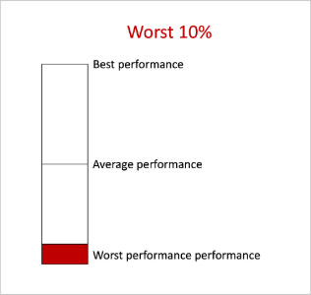
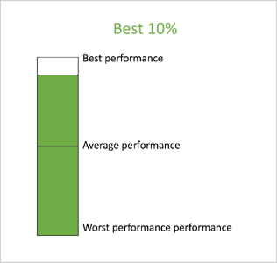
Figure 1. Fake normative feedback was presented to people in the negative condition (left) and positive condition (right). Additionally, those in the control condition were simply notified that they had “completed the first block of problems.”
Results.
For brevity, the following section focuses on the critical block x feedback and block x feedback x conflict interactions which speak to whether feedback affected our key variables, however, the full results are available in the supplemental information. Deviating from the preregistration slightly, to improve consistency across studies, Studies 1 and 2 used the exclusion criteria that was later pre-registered and imposed for Studies 3 and 4. Specifically, we removed trials on which response times exceeded >3SD from the mean and log transformed response times when used as a dependent variable. All other aspects of the analyses were preregistered.
Accuracy. To examine whether shifts in accuracy were impacted by feedback condition or conflict, we used a logistic model regressing block (pre-feedback, pot-feedback), feedback (negative, control, positive), conflict (conflict, no conflict), and their interactions on accuracy (0, 1) with by-subject random intercepts and slopes for conflict and block (1 + conflict + block || ID). The model revealed a conflict × feedback × block interaction effect on accuracy (χ2(2)=29.53, p<.001). Follow-up analyses revealed that, for people receiving negative feedback, there was a positive difference between pre-feedback and post-feedback for conflict items (β = 1.77, SE = 0.37, p = .001). Whereas there was a negative difference between pre-feedback and post-feedback for no conflict items (β = –1.67, SE = 0.39, p < .001). However, there was no effect of feedback for the positive or control conditions. This suggests that negative–but not control or positive feedback–prompted participants to change their response strategies, but not always for the better. See Figure 2A and SI 1.1.
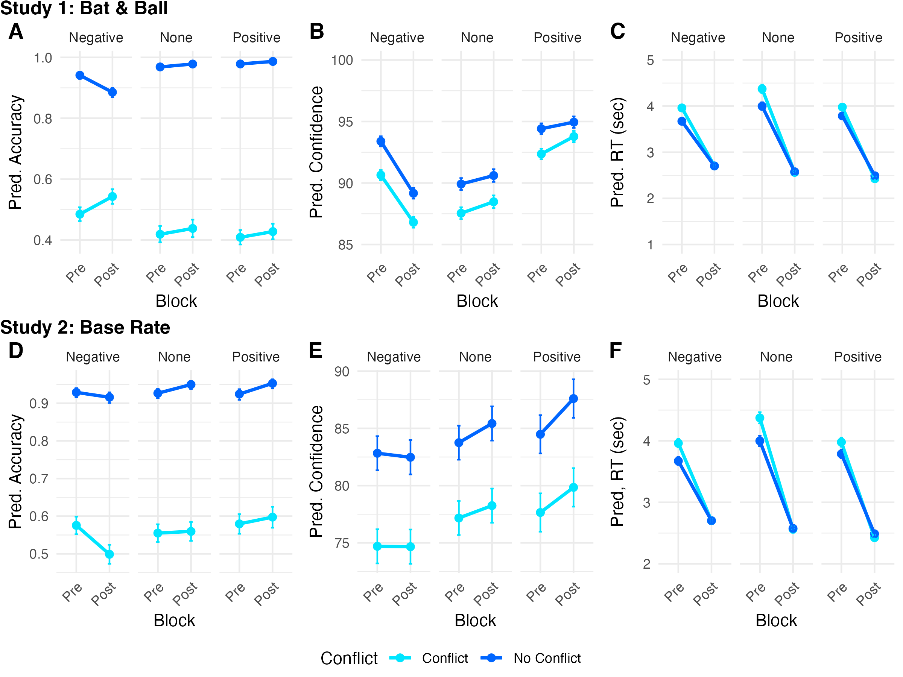
Figure 2. Results from Studies 1-2 showing that negative feedback affects accuracy (A), confidence (B), and response times (C) differently for negative versus none or positive feedback. Error bars are +/- 1SE.
Confidence. To examine whether changes in confidence were impacted by feedback condition or conflict, we used a linear mixed model regressing block (pre-feedback, post-feedback), feedback (negative, control, positive), conflict (conflict, no conflict), and their interactions on confidence (rescaled to a percentage 0-100) with by-subject random intercepts and slopes for conflict and block (1 + conflict + block || ID). The critical block × feedback interaction was significant (F(2, 297)=7.59, p<.001). Contrasts revealed that confidence dropped from pre-feedback to post-feedback for those in the negative feedback condition (t(297)=-4.08, p<.001), whereas those in the control (t(297)=0.79, p=.502) and positive feedback conditions (t(297)=0.96, p=.362) showed no change. See Figure 2B and SI 1.2.
Response time. To examine whether shifts in response times were impacted by feedback condition or conflict, we first excluded response times over 3SD (67/18000 trials removed) and log transformed those remaining. We then used a linear mixed model, regressing block (1, 2), feedback (negative, control, positive), conflict (conflict, no conflict), and their interactions on response time (seconds).The model included by-subject random slopes for conflict and block (1 + block || ID). Conflict was removed due to singularity. The critical block x feedback interaction effect was significant (F(2, 297)=4.82, p=.009). Interaction contrasts revealed that the effect of block was significantly different between each of the feedback conditions. The block effect was smaller for negative than the control (t(297)=2.85, p=.004) and positive (t(297)=2.34, p=.019) conditions. While the block effect was no different for the control and positive conditions (t(297)=-.62, p=.531). These findings suggest that even though people generally speed-up when they solve the second block of problems, this effect is less pronounced in the negative feedback condition. Hence, relative to the other conditions, participants receiving negative feedback showed signs of greater deliberation during Block 2. See Figure 2C and SI 1.3.
Confidence and response time. To assess whether low confidence was associated with longer reaction times, we used a linear mixed model, regressing confidence on response time with participant and item as random intercepts. The same exclusion criteria were enforced as for response times above. As in previous studies, there was a small but significant negative relationship between confidence and response time (β = -9.48e-04, p = .026). See SI 1.4.
Study 2: Base-rate Problems – Single Response
In Study 1, we found that feedback impacted accuracy, confidence, and response times for people solving the ubiquitous bat and ball problems. Specifically, those in the negative feedback condition improved their performance on conflict items but decreased their performance on no conflict items, while those in the control and positive feedback conditions showed no changes in performance. Regarding confidence, those in the negative feedback condition showed a decrease but there was no change for those in the control or positive feedback conditions. At the same time, those in the negative feedback condition showed longer response times after feedback relative to the participants in the control and positive feedback conditions. In line with previous work, confidence was negatively associated with response time across feedback conditions. Collectively, these findings suggested that we can use this paradigm to manipulate confidence on the bat and ball problem but was not clear if this would generalize to others. We therefore ran an additional study, validating the fake feedback paradigm with another classic reasoning task inspired by the seminal work of Kahneman and Tversky (1973), the base rate problem in which people are faced with a personality description and statistical base-rate information that can cue conflicting responses.
Method
Participants. Three hundred US participants were recruited online via Prolific and paid £4 (146 females, mean age = 39.27, SD = 12.93 years; participants from Study 1 were prevented from participating). As in Study 1, participants were randomly allocated to one of the three feedback conditions and those in the positive and negative feedback conditions were debriefed.
Materials. Each participant answered 60 base-rate problems. We adopted the “short” format introduced by Pennycook et al. (2015). From a larger pool of 132 items, participants were randomly assigned 30 conflict and 30 no-conflict problems. Half of the items in each block were conflict and half were no conflict, their order was randomised. As for Study 1, due to a carried-forward programming error, 32 items were presented in the pre-feedback block and 28 in the post-feedback block. For no-conflict items, the base rate probability and the stereotype descriptor cued the same response (e.g., “This study contains computer programmers and construction workers. Person D is strong. There are 4 computer programmers and 996 construction workers. Person D is more likely to be:” ['a computer programmer', 'a construction worker']) whereas, for conflict items, they cued different responses (e.g., “This study contains computer programmers and construction workers. Person C is nerdy. There are 4 computer programmers and 996 construction workers. Person C is more likely to be:” ['a computer programmer', 'a construction worker']). The base rates were always: 997:3, 996:4, or 995:5 (Pennycook et al., 2014). Notably, the instructions stressed that the person was drawn randomly from the sample.
Procedure. Study 2 followed a similar procedure as Study 1. At the beginning of the study, participants were presented with the same general instructions and answered two practice items. For all items, after responding to the reasoning problem, participants indicated how confident they were in their response (1-6). After pre-feedback items, they received feedback in accordance with their condition (see Figure 1). Finally, participants responded to brief demographic questions.
Results
As for Study 1, for brevity, we focus on the critical block x feedback and block x feedback x conflict interactions. We also adopted the exclusion and transformation protocol from Studies 3-4.
Accuracy. To examine whether shifts in accuracy were impacted by feedback condition or conflict, we used a logistic model regressing block (pre-feedback, post-feedback), feedback (negative, control, positive), conflict (conflict, no conflict), and their interactions on accuracy (0, 1) with by-subject random intercepts and slopes for conflict and block (1 + conflict + block || ID). The critical block × feedback interaction was significant (χ2(2) = 12.02, p=.002). Accuracy increased from pre- to post-feedback for none (β = 0.52, p = .004) and positive conditions (β = 0.61, p = .002) but not the negative condition (β = -0.18, p = .290). See Figure 2D and SI 2.1.
Confidence. To examine whether shifts in confidence were impacted by feedback condition or conflict, we used a linear mixed model regressing block, and conflict, and all interactions on confidence (as a percentage) with by-subject random intercepts and slopes for conflict and block (1 + conflict + block || ID). Critically, there was a significant block x feedback effect (F(2, 297)=3.39, p=.035). Contrasts confirmed that confidence increased significantly for those in the positive conditions (t(297)=2.70, p=.001), showed a marginal increase for those in the control condition (t(297)=1.31, p=.075), but not for the negative condition (t(297)=-0.18, p=.812). See Figure 2E and SI 2.2.
Response times. To examine whether changes in response times were impacted by feedback condition or conflict, we first excluded trials with response times >3SD (146/18000 trials removed) and the remaining were log transformed. We then used a linear mixed model, regressing block (pre-feedback, post-feedback), feedback (negative, control, positive), conflict (conflict, no conflict), and their interactions on response times. The model included by-subject random slopes for conflict and block (1 + block || ID). Conflict was removed due to singularity. The block x feedback interaction was significant (F(2, 297)=4.82, p=.009). Interaction contrasts revealed that the drop in response time was smaller for the negative than the control condition (t(297)=-2.85, p=.005) and positive condition (t(297)=2.35, p=.019), and that there was no difference between the drop for control and positive conditions (t(297)=0.63, p=.531). As in Study 1, these findings suggest that, relative to the other conditions, participants receiving negative feedback spent more time deliberating post feedback. See Figure 2F and SI 2.3.
Confidence and response time. To assess whether low confidence was associated with longer reaction times for base rate problems, we used a linear mixed model, regressing confidence on response time with participant and item as random intercepts. The same exclusion criteria were enforced as for response times above. In line with previous studies, there was a small but significant negative relationship between confidence and response time (β = -3.29e-03, p < .001). See SI 2.4.
Study 3: Bat and Ball – Two Response
In Study 2, we demonstrated that the fake feedback paradigm can be used to experimentally manipulate performance, confidence and response times not only for the bat and ball task but also for the widely used base rate problems. As for Study 1, the findings suggest that negative feedback had a different effect on confidence and response times relative to the control or positive feedback conditions. Again, we observed a negative association between confidence and response times, suggesting confidence and deliberation may be linked. However, because confidence for each trial was recorded after the response was made, our design cannot rule out issues of directionality–that is, the possibility that longer response times may lead to lower confidence, rather than low confidence leading to longer response times. Relatedly, we cannot be sure that longer response times necessarily reflect greater deliberation—that is, the engagement of effortful, cognitive resources.
To address potential issues regarding directionality and the measurement of deliberation, in Studies 3 and 4, we presented trials before and after feedback in a ‘two-response’ format (Thompson et al., 2011). For each trial, participants provided two responses to the reasoning problem: An initial, “intuitive” response, followed by a final, “deliberative” response. To encourage the use of intuitive processing at Response 1, a time limit of four seconds was imposed for bat and ball problems (Study 3) and three seconds for base rate problems (Study 4). These time limits were successful in preventing deliberation in previous studies (Bago & De Neys, 2020; Raoelison & Neys, 2019). After both the initial and the final response, participants also reported their confidence in their responses.
This design gives several advantages when testing the relationship between confidence and deliberation. First, confidence recorded after Response 1 precedes reasoning at Response 2, meaning that we can examine the relationship between confidence at time 1 and deliberation at time 2 – thus, addressing the potential directionality issue. Second, participants have the chance to change their answer at Response 2, which – if it occurs – provides a conservative but strong indication that the participant has engaged in further deliberation. That is, while some participants may additionally deliberate at Response 2 but not change their answers, those that do are highly likely to have thought more deeply about the problem at hand (Thompson et al., 2011). Hence, in Studies 3 and 4, we were able to gain a deeper understanding of the confidence-deliberation relationship by examining the relationships between confidence at Response 1 and response times at Response 2, and confidence at Response 1 and answer change at Response 2.
Method
Participants. Three hundred and nine US participants were recruited online via Prolific and paid £4.00 (157 females, mean age = 40.41 years, SD = 12.65). As in Studies 1 and 2, participants were randomly allocated to one of the three feedback conditions and those in the negative and positive feedback conditions were debriefed.
Materials. As in Study 1, participants responded to 30 conflict and 30 no-conflict bat and ball problems, randomly selected from a larger pool of 100 items. Thirty items were presented in each block, half of which were conflict and half of which were no-conflict items (order randomised within block). In contrast to Studies 1 and 2, the items were presented in a two response format (Thompson et al., 2011) such that participants responded to each problem twice, initially under a time constraint and, again, without constraints. As shown in Figure 3, for each trial, participants were presented initially with a fixation cross for 1000ms, the first part of the question for 2000ms (e.g., “In a building residents have 370 dogs and cats in total."), then the full question and response options for 4000ms or until a response was made (e.g., “In a building residents have 370 dogs and cats in total. There are 300 more dogs than cats. How many cats are there ?" [35, 70]). Here, the screen background turned yellow when there was 1000ms remaining to warn the participant that the deadline was approaching. If they did not respond before the deadline, they were instructed to do so on subsequent trials. If they responded before the deadline, they were then asked how confident they were in this first response (1-6). Next, participants were presented with the full question again (without time restriction) and asked how confident they were in this second response (1-6).
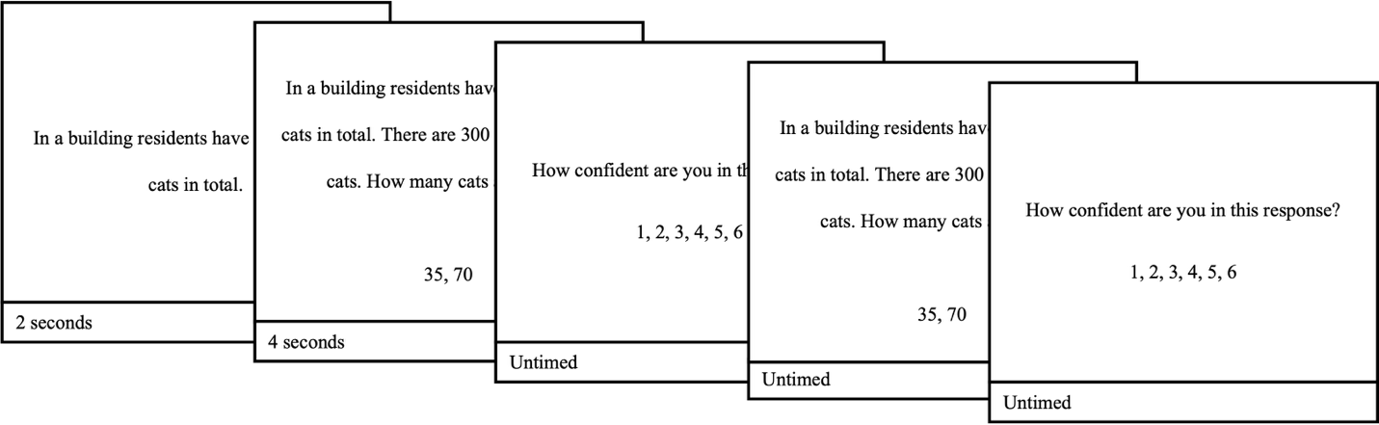
Figure 3. Studies 3-4 employed two-response paradigms such that participants responded to each item twice, the first time under a strict time-limit and the second time without restriction.
Procedure. Participants were given the same general instructions as provided in Studies 1-2. Additionally, participants were instructed that for each problem, we were interested in their very first, initial response that came to mind, and that they would have the chance to spend additional time reflecting during their second, final attempt. They then completed two practice problems as described in Figure 3. Participants then completed pre-feedback items, followed by feedback in accordance with their condition (see Figure 1), and then post-feedback items. In the feedback for Studies 3 and 4, we clarified that it related to their performance at Response 2 (see the Appendix for the full instructions and feedback). Participants could respond using the same keystrokes as in Studies 1-2. After the post-feedback items, participants responded to brief demographic questions.
Results
As for Studies 1-2, for brevity, we focus on the key feedback x block and feedback x block x conflict effects. All trials on which participants did not respond before the deadline at Response 1 were removed (241 of 18540 trials removed). For analyses involving response times, we removed trials for which the response time at Response 2 exceeded 3SD above the mean (179 of 18299 trials removed). Response times were also log transformed when examined as a dependent variable.
Accuracy. To examine whether changes in accuracy at Response 1 or 2 were affected by conflict or feedback, we employed logistic models regressing block (pre-feedback, post-feedback), feedback (negative, control, positive), and conflict (conflict, no conflict) on accuracy at Response 1 (0,1) and then Response 2 (0,1), with by-subject random intercepts and slopes for conflict and block (1 + conflict + block || ID). For Response 1, there was a three-way effect of conflict x feedback x block (χ2(2) = 78.26, p <.001). As seen in Figure 5A, for conflict items, those in the negative condition became more accurate (β =1.04, p <.001), while those in the none (β =-.23, p = .089) and positive (β =-.02, p = .900) conditions showed no change. For no conflict items, those in the control (β =.58, p =.008) and positive (β =.47, p =.002) conditions became slightly more accurate, while those in the negative condition (β =-.06, p = .644) showed no change (see Figure 4A and SI 3.1.1).
For Response 2, there was a three-way effect of conflict x feedback x block (χ2(2) = 64.71, p <.001). As seen in Figure 4B, for conflict items, those in the negative condition became more accurate (β =1.73, p <.001), and those in the none (β =.44, p =.024) and positive (β =.50, p =.015) improved to a lesser extent. For no conflict items, those in the negative condition showed no change (β =-.07, p =.729) while those in the none (β =.82, p <.001) and positive (β =.58, p =.009) conditions became slightly more accurate (see Figure 4B and SI 3.1.2).
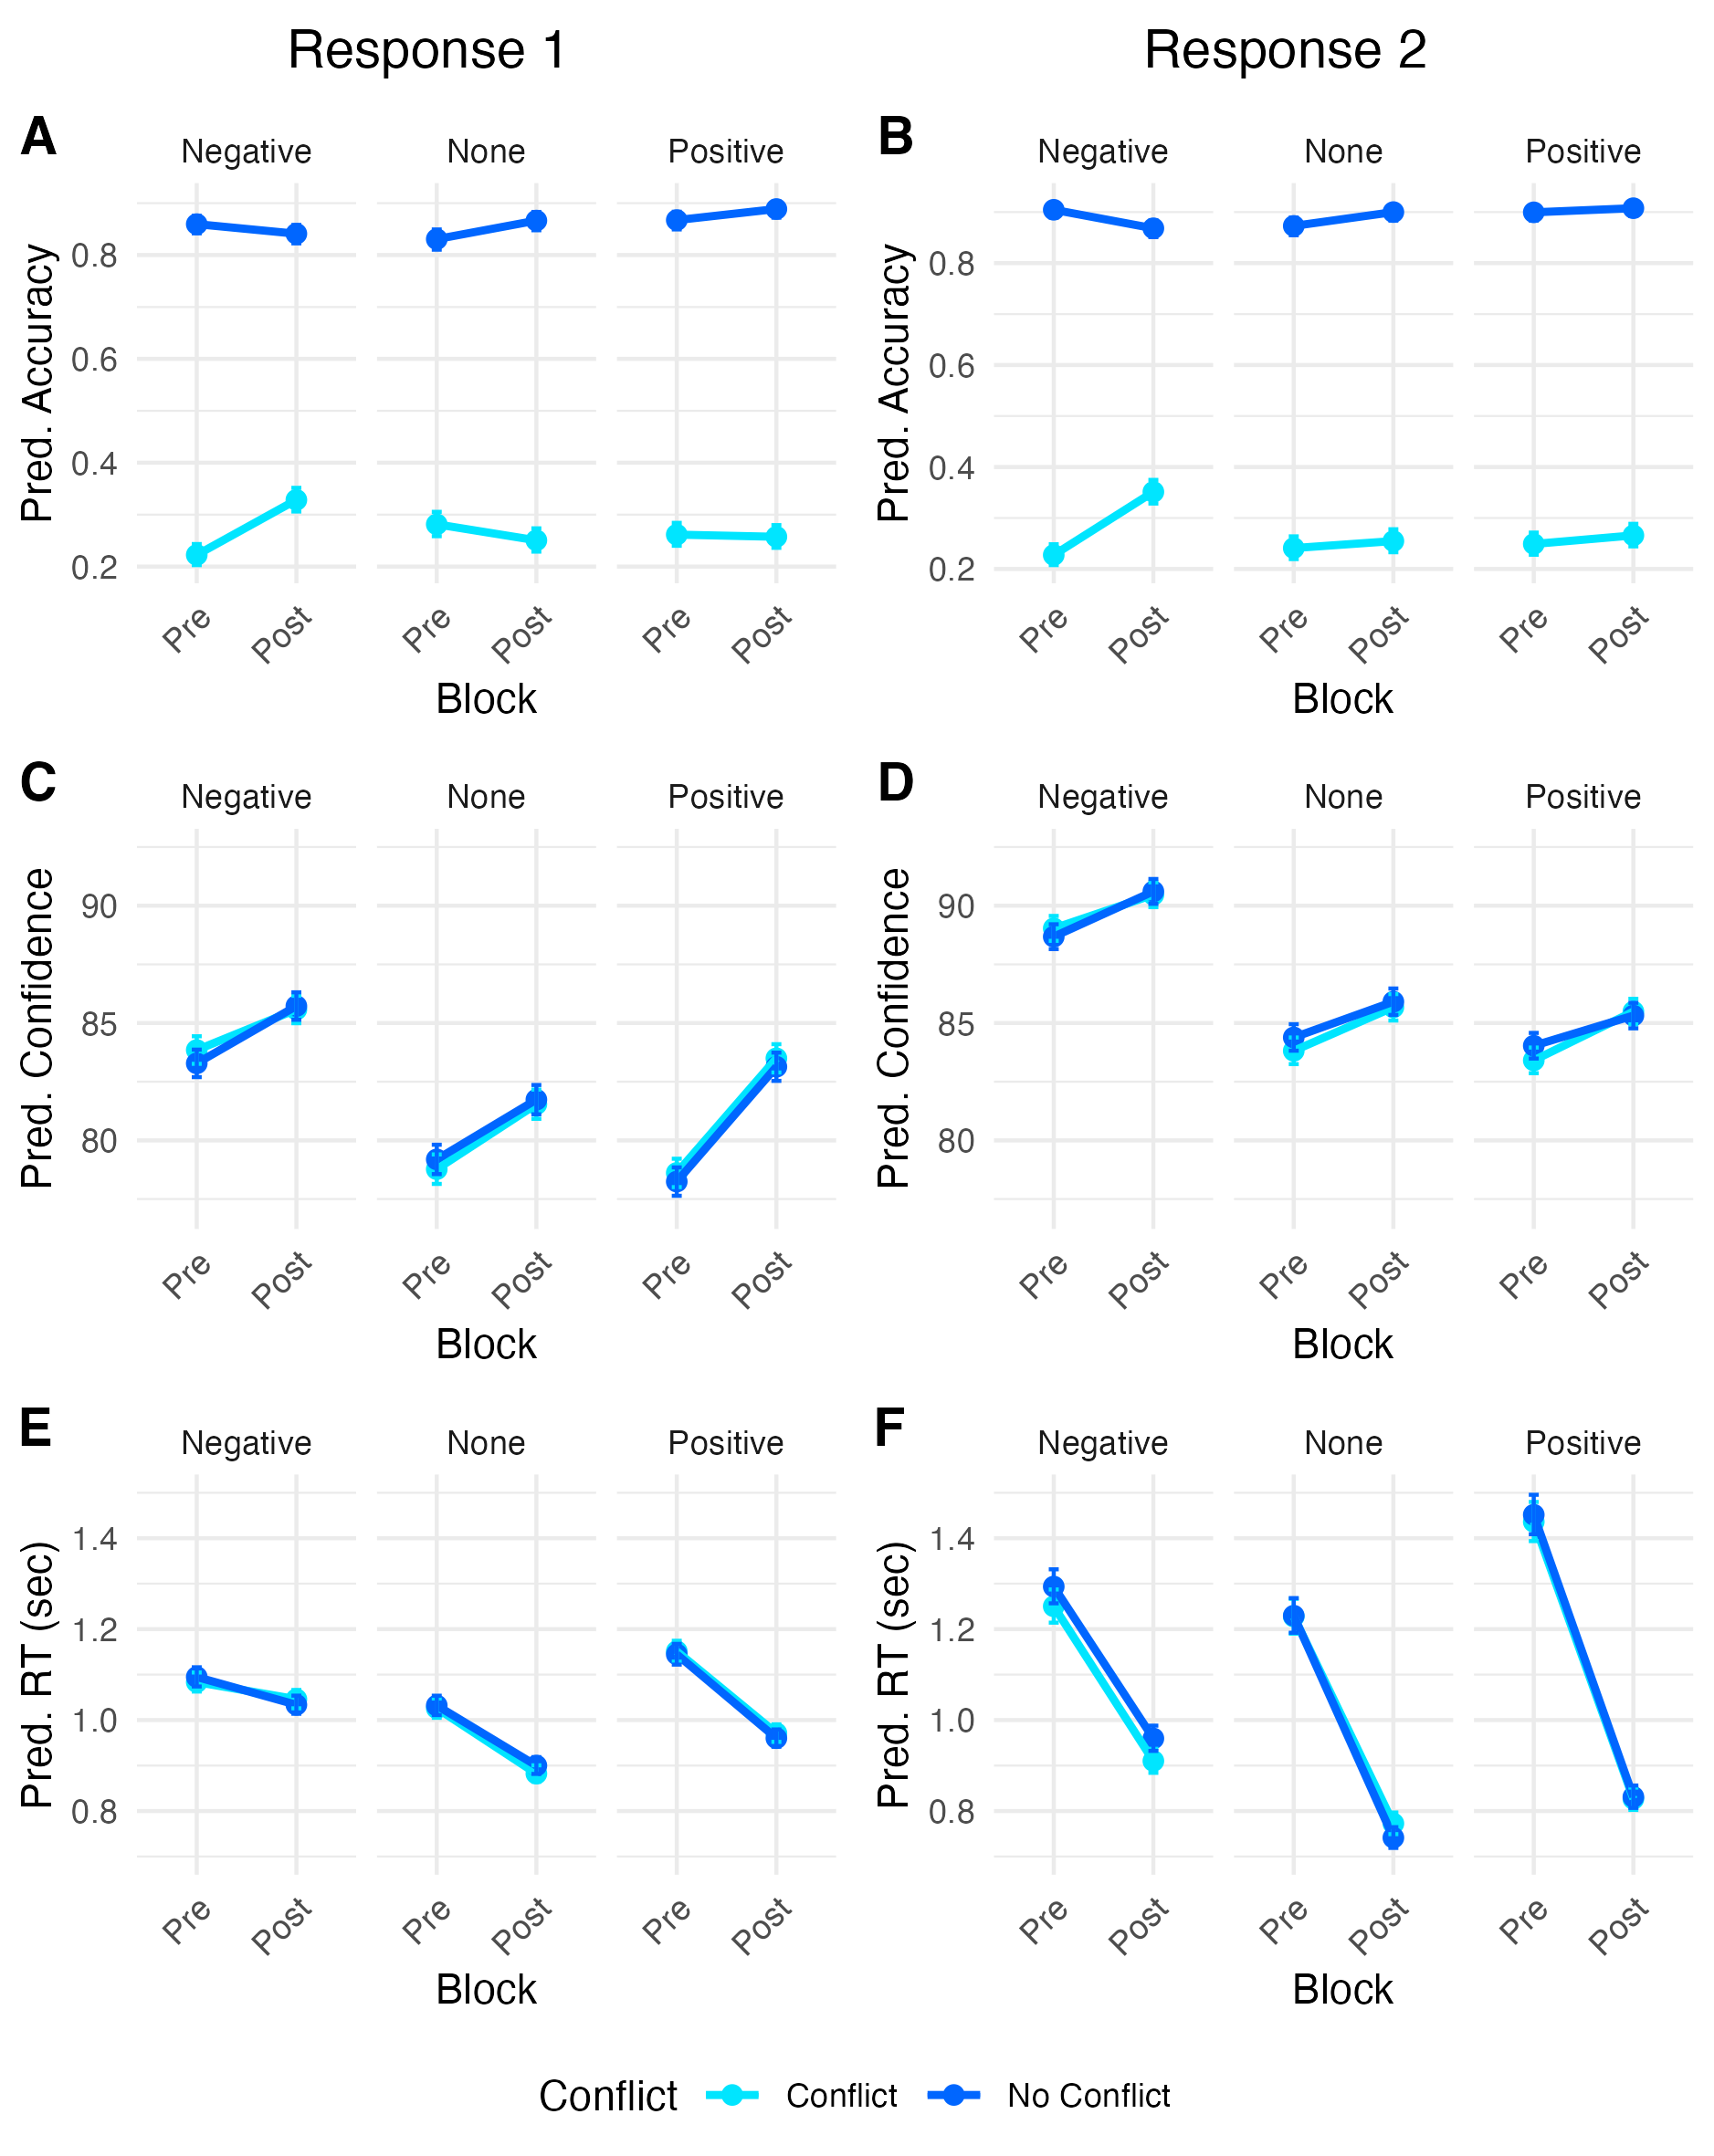
Figure 4. Simple results Study 3, showing conflict dependent accuracy effects (A-B), stronger increases in confidence for control and positive conditions (C-D), and a smaller reduction in RTs negative than control or positive feedback (E-F). Error bars are +/- 1 SE.
Confidence. To assess whether changes in confidence were influenced by feedback and conflict, we regressed conflict x feedback x block on confidence separately for confidence at Response 1 and confidence at Response 2 with by-subject random intercepts and slopes for conflict and block (1 + conflict + block || ID). For Response 1, there was a two-way block x feedback interaction (F(2, 305) = 3.07, p = .048). Confidence increased for all conditions; however, this increase was smaller for negative than positive feedback (β = 2.89, p = .020). There was no difference in the changes in confidence between none and negative (β = 0.49, p = .700) or none and positive (β = 2.41, p =.060). At Response 2, the feedback x block (F(2, 305) = .01, p =.988) and feedback x block x conflict (F(2, 17378) = 1.38, p =.252) effects were not significant. These results suggests that feedback impacted confidence at Response 1 but not Response 2. See Figure 4C-D and SI 3.2.
Response times. To examine whether changes in response times differed by feedback condition or conflict, we used a linear mixed model, regressing block (pre-feedback, post-feedback), feedback (negative, control, positive), conflict (conflict, no conflict), and their interactions. The model included by-subject random slopes for conflict and block (1 + block || ID). Conflict was removed due to singularity. The key block x feedback interaction was significant (F(2, 305) = 5.15, p=.006). Response times at Response 1 were shorter in post-feedback than pre-feedback for control (β =-0.15, p < .001) and positive conditions (β =-0.18, p < .001) but not negative (β = -0.05, p = .115). Similarly, at Response 2, we observed a significant block x feedback interaction (F(2, 305)=4.57, p=.011). Response times at Response 2 were shorter in post-feedback than pre-feedback for all conditions, however, this drop was significantly shorter for the negative compared to positive (β =.26, p = .004) or control conditions (β =.19, p = .035). The drop was no different between control and positive conditions (β =.07, p =.455). As in Studies 1 and 2, these findings suggest that negative feedback was associated with longer response times, relative to the control and positive conditions, and that negative feedback may have prompted greater deliberation. See Figures 4E-F and 5A, and SI 3.3.
Feedback and answer change. To assess whether feedback impacted answer change, we created a binary answer change factor: trials for which participants gave the same answer at Response 1 and Response 2 were coded 0 and those with different answers were coded 1. We then used a logistic mixed model regressing conflict, block, and feedback and all their interactions on this index with by-subject random slopes for conflict and block (1 + conflict + block || ID). The critical block x feedback interaction was significant (χ2(2) =12.61, p =.002). The likelihood of answer change decreased from pre-feedback to post-feedback for all conditions. However, this decrease was smaller for the negative condition than for the positive (β = .52, p =.009) and control (β = .47, p =.017) conditions. There was no difference in the decrease between control and positive (β = 0.05, p = .803). These findings suggest that negative feedback was associated with a greater likelihood of answer change—a key indicator of deliberation—relative to the control and positive conditions. See Figure 5B and SI 3.4.
Confidence and response times. To examine the relationship between confidence at Response 1 and response times at Response 2, we regressed confidence at Response 1 on response times at Response 2 with participant as a random intercept. The effect of confidence was statistically significant and negative (β =-0.23, p < .001). This finding again supports the idea that lower confidence may prompt extended deliberation. See Figure 5C and SI 3.5.
Confidence and answer change. To examine whether lower confidence at Response 1 was associated with answer change from Response 1 to Response 2, we used a logistic mixed model to regress confidence on answer change (0, 1) with participant as a random intercept. The effect of confidence at Response 1 was statistically significant and negative (β = -0.04, p < .001). These findings are in line with the idea that lower confidence may be related to greater deliberation. See Figure 5D and SI 3.6.
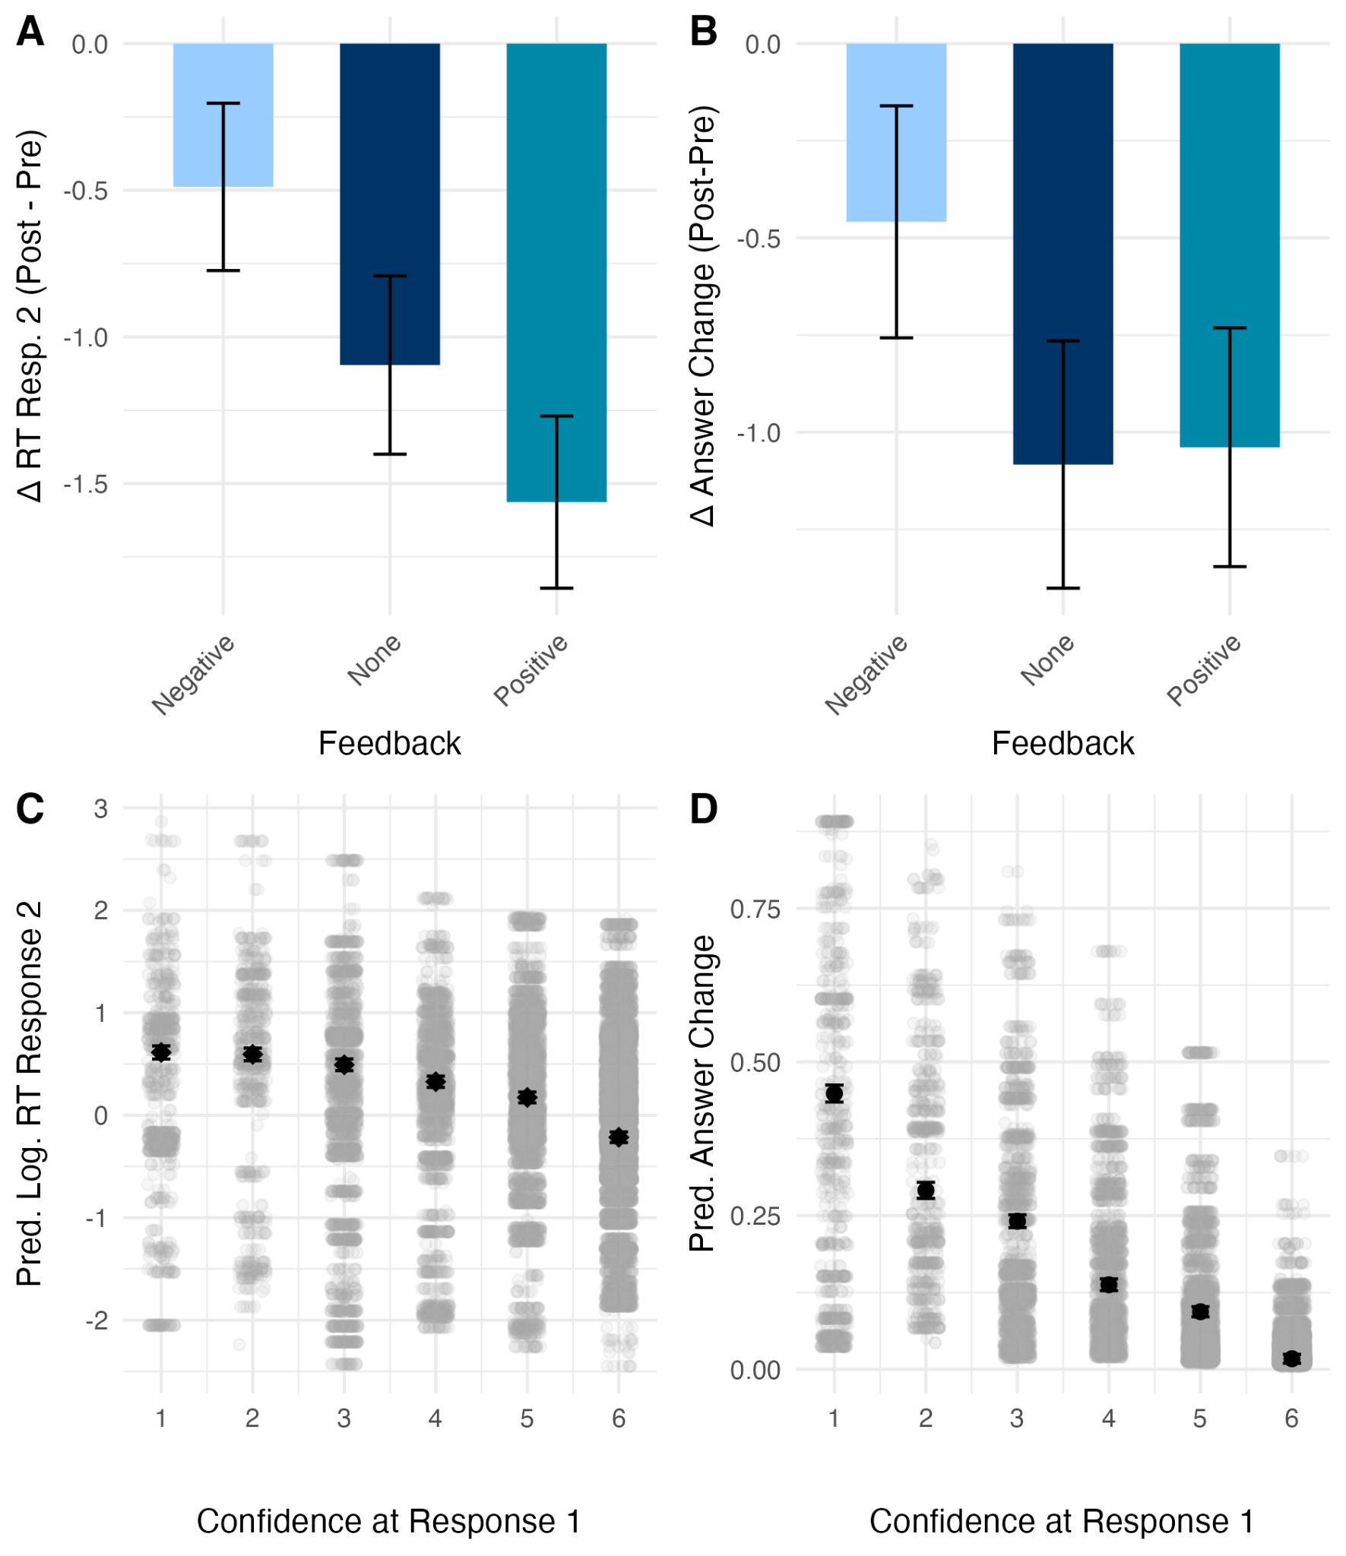
Figure 5. Confidence and deliberation results for Study 3. Panel A shows the change in mean RTs from pre- to post-feedback: mean RTs became faster for those in the control and positive conditions but not the negative feedback condition. Panel B shows the change in the sum of answer change trials from pre- to post-feedback: this decreased for those in the negative condition to a lesser extent than it did for those in the positive or control conditions. Panels C and D show that low confidence at Response 1 was linked to longer response times and higher probability of answer change at Response 2. Error bars are +/- 1.
Study 4: Base Rate – Two Response
Study 3 demonstrated that, for the bat and ball problem, feedback could impact not just confidence and response times but also answer change. Specifically, negative feedback led to lower confidence, longer reaction times and a greater likelihood of answer change than positive or no feedback. At the same time, confidence – in this case reported before the possibility of deliberation – was negatively related to both response times and answer change. While these results provide causal evidence for the confidence-deliberation hypothesis, we wanted to see whether they generalised to other tasks. Hence, in Study 4 we again employed base rate problems.
Method
Participants. Three hundred US participants were recruited online via Prolific and paid £4.00 (152 females, mean age = 41.68, SD = 13.68 years). As in Studies 1-3, participants were randomly allocated to one of the three feedback conditions.
Materials. Study 4 employed a similar design structure as Study 3, however, participants were presented with base rate problems. As in Study 2, 30 conflict and 30 no conflict items were selected from a pool of 132 problems. Thirty items were presented in each block and, according to their condition, participants were presented with feedback (negative, control, or positive) after pre-feedback items. As in Study 3, items were presented in a two-response format such that participants responded to each item twice, the first time under a strict time limit (see Figure 3). This protocol was identical to Study 3 with the exception of the presentation of the item for Response 1. In this case, following the fixation cross, first, the composition of the sample was presented for 2000ms (e.g., “This study contained accountants and clowns.”), then the base rate was added for 2000ms (e.g., “This study contained accountants and clowns. There were 995 accountants and 5 clowns.”) and, finally, the description and response options for 3000ms or until the participant made a response (e.g., “This study contained accountants and clowns. There were 995 accountants and 5 clowns. Person X is funny. Person X is more likely to be: [an accountant, a clown]”). Otherwise, trials followed the same protocol as in Study 3, see also Figure 2.
Procedure. Participants received the same general instructions as in Study 3, they then completed two practice items, completed pre-feedback items, received feedback, completed post-feedback items, answered demographic questions, and were debriefed.
Results
As for Study 3, for brevity, the following section reports only the highest order significant effects within each of the models and focuses on the important feedback x block effects. However, comprehensive results are provided in the SI4 as indicated. As above, all trials on which participants did not respond before the deadline on Response 1 or for which they did not answer the grid pattern correctly were removed (264 of 17880 trials removed). Analyses involving response times removed trials on which the response time at Response 2 exceeded 3SD above the mean (92 out of 17616 trials removed) and response times were log transformed when response time was a dependent variable. All exclusion criteria and analyses were preregistered.
Accuracy. To examine whether feedback affected accuracy, we employed logistic models regressing block (pre-feedback, post-feedback), feedback (negative, control, positive), and conflict (conflict, no conflict) on accuracy at Response 1 (0,1) and then Response 2 (0,1) with by-subject random slopes for conflict and block (1 + conflict + block || ID). For Response 1, neither the feedback x block ((χ2(2) = .30, p = .859) nor the conflict x feedback x block interaction was significant ((χ2(2) = 3.74, p =.154). Likewise, at Response 2, the block x feedback interaction was not significant ((χ2(2) = 4.48, p=.106) nor the conflict x feedback x block interaction ((χ2(2) = 3.43, p =.180). See Figure 6A-B and SI 4.1
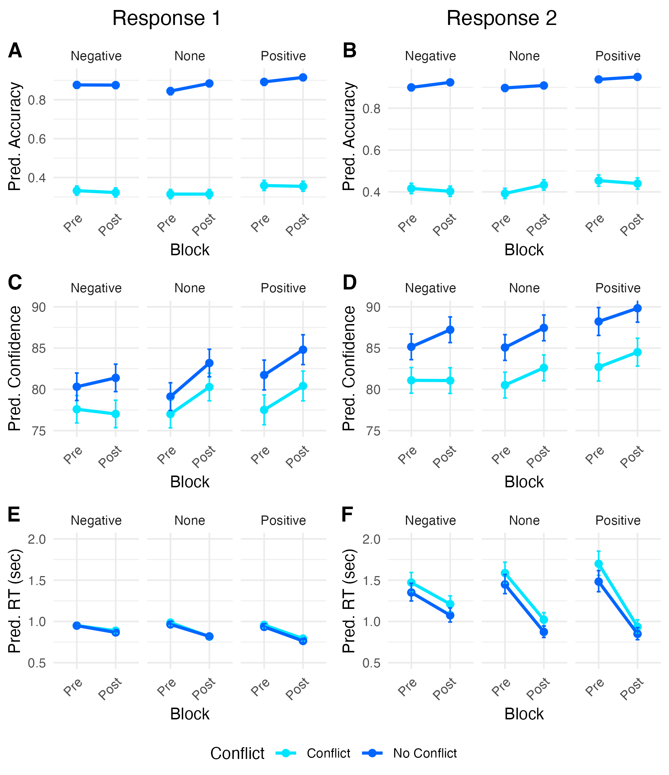
Figure 6. Simple results Study 4, showing conflict dependent accuracy effects (A-B), stronger increases in confidence for control and positive conditions (C-D), and a smaller reduction in RTs negative than control or positive feedback (E-F). Error bars are +/- 1 SE.
Confidence. To examine whether confidence was affected by feedback, we regressed conflict, feedback, block, and all their interactions on confidence separately for confidence at Response 1 and confidence at Response 2 with by-subject random slopes for conflict and block (1 + conflict + block || ID). For Response 1, the feedback x block interaction was significant (F(2, 295) = 3.43, p = .034). There was no effect of block for negative feedback (β =.27, p=.783). However, confidence increased for those in the control (β =3.66, p<.001) and positive conditions (β =2.94, p = .005). For Response 2, there was also a significant conflict x feedback x block interaction (F(2, 16723) = 3.36, p = .035). Confidence increased from pre- to post-feedback for all combinations of conflict and feedback (β > 1.63, p values < .05) except conflict items for those in the negative condition which did not change (β =-0.04, p=.962). These suggest that, after feedback, confidence was lower for those in the negative feedback condition relative to the control and positive conditions for both conflict and no-conflict items at Response 1 and conflict items at Response 2. See Figure 6C-D and SI 4.2.
Response times. To assess whether response times changed as a function of feedback, we used a linear mixed model, regressing block (pre-feedback, post-feedback), feedback (negative, control, positive), conflict (conflict, no conflict), and their interactions on response times at Response 1 and response times at Response 2. The model included by-subject random slopes for conflict and block (1 + block || ID). Conflict was removed due to singularity. For Response 1, the block x feedback interaction was significant (F(2, 295)=3.67, p=.027). Response times dropped in Block 2 for all conditions, however, this drop was larger for the negative versus control (β =0.10, p=.032) and positive conditions (β =0.11, p=.014). However, there was no difference in the drop between positive and no conditions (β =.02, p = .692). For Response 2, there was a significant two-way feedback x block effect (F (2, 295) = 12.06, p <.001). Response times shortened for participants in all conditions. However, this reduction was smaller for those in the negative condition than those in the none (β =0.27, p<.001) and positive conditions (β =0.37, p<.001). There was no difference in the drop for control and positive conditions (β =0.10, p=.218). These results suggest that feedback affected response times at Response 1 and Response 2. See Figures 6E-F and 7A, and SI 4.3.
Answer change and feedback. As for Study 3, to formally assess whether feedback impacted answer change, trials on which participants gave the same answer at Response 1 and Response 2 were coded 0 and different answers were coded 1. We then used a logistic mixed model regressing conflict, block, and feedback and all their interactions on this index with by-subject random slopes for conflict and block (1 + conflict + block || ID). The block x feedback effect was significant (χ2(2) = 6.54, p =.038). Answer change was less likely in post-feedback for those in the control (β = -.49, p = .003) and positive conditions (β = -.46, p = .012), but no different for those in the negative condition (β = .04, p = .817). These results suggest that relative to control and positive feedback conditions, negative feedback led to a greater likelihood of answer change. See Figure 7B and SI 4.4.
Confidence and response times. To test whether confidence at Response 1 was to response times at Response 2, we regressed confidence at Response 1 on response times at Response 2 with a random intercept for participant. The effect of confidence was statistically significant and negative (β =-0.25, p < .001). This finding supports the conjecture that lower confidence precedes longer deliberation and that lower confidence may trigger deliberation. See Figure 7C and SI 4.5.
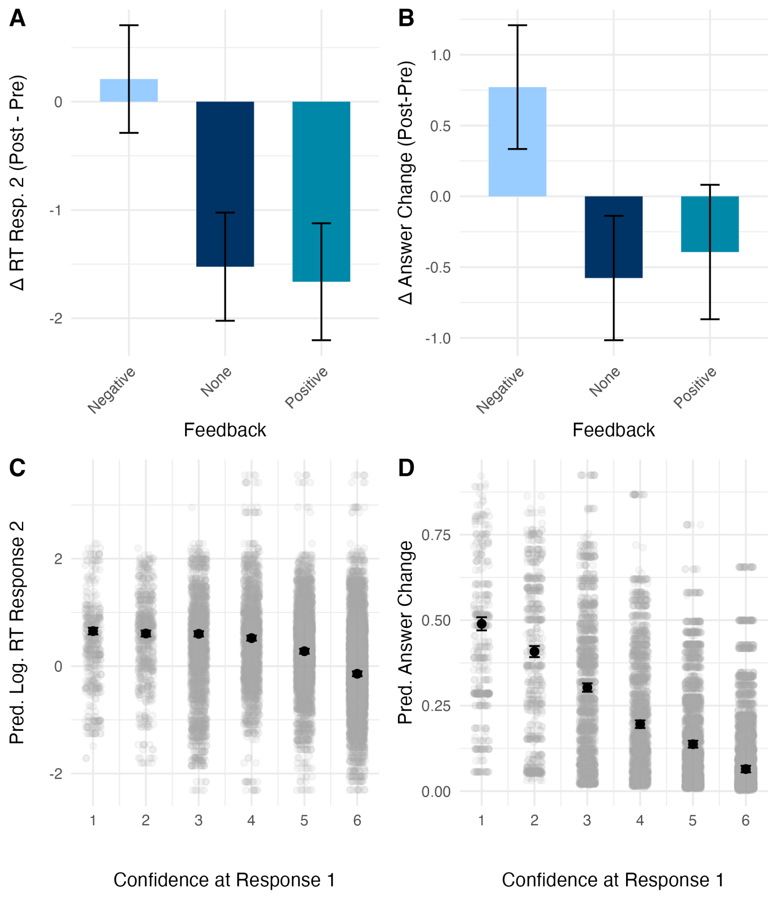
Figure 7. Confidence and deliberation results, Study 4. Panel A shows the average change in mean RTs from pre- to post-feedback: mean RTs became faster for those receiving control and positive but not negative feedback. Panel B shows the average change in the sum of answer change trials from pre- to post-feedback: those in the negative condition increased the number of answer-change trials while this decreased for those in the control and positive conditions. Panels C and D show that low confidence at Response 1 was linked to longer response times and higher probability of answer change at Response 2. Means and +/- 1 SE for each level of confidence are shown in black.
Answer change and confidence. To test whether there was a relationship between confidence at Response 1 and answer change from Response 1 to Response 2, we used a logistic mixed model to regress confidence on answer change (0, 1) with participant as a random effect. The effect of confidence at Response 1 was statistically significant and negative (β = -0.84, p < .001). This lends support to the idea that lower confidence may be related to greater deliberation. See Figure 7D and SI 4.6.
General Discussion
Across four preregistered studies, we tested whether confidence plays a causal role in regulating deliberative reasoning. Using fake normative feedback to experimentally manipulate confidence, we observed consistent effects across multiple reasoning tasks and response formats on indicators of confidence and deliberation. Participants told they performed poorly (negative feedback) reported lower confidence, showed less reduction in response times, and were more likely to revise their answers. Moreover, confidence—recorded at Response 1—predicted Response 2 response times and answer revision, key indicators of deliberation. Feedback also affected accuracy but not necessarily for the better, suggesting that reductions in confidence trigger sustained cognitive engagement but this alone is not sufficient for improving performance.
This pattern was evident across all four studies. In Studies 1 and 2, using bat-and-ball and base-rate problems, we validated the confidence manipulation paradigm: negative feedback reliably reduced confidence and dampened the typical speed-up in response times across blocks. Participants in the negative condition sometimes improved on conflict problems (Study 1), but also exhibited decreased accuracy on no-conflict items, consistent with a shift in reasoning strategy rather than a general performance benefit. In Studies 3 and 4, which employed a two-response design, feedback again modulated confidence and response times, with negative feedback leading to more sustained deliberation at both initial and subsequent response stages. Critically, early confidence predicted both later response times and the likelihood of changing one's answer, and participants in the negative condition were more likely to revise their initial response (though not necessarily for the better). These findings collectively demonstrate that confidence is not merely epiphenomenal but can causally shape reasoning behavior.
A consistent relationship between confidence and response time emerged across studies. Participants who received negative feedback, and who consequently reported lower confidence, exhibited smaller reductions in response time over blocks. Moreover, across tasks and response stages, confidence was negatively associated with response time: lower confidence predicted longer deliberation. These effects are consistent with models of metacognitive control in which subjective confidence informs the allocation of cognitive effort (Ackerman & Thompson, 2017; Purcell et al., 2022). In particular, these findings align with the view that low confidence can serve as a cue to invest additional processing resources, thereby extending the duration or depth of reasoning. However, response time is only one indicator of deliberation and, arguably, less informative than answer change.
The increased likelihood of answer change in Studies 3 and 4 provides strong support for the regulatory role of confidence. Participants who received negative feedback were more likely to revise their responses during second-stage reasoning, and lower initial confidence predicted greater revision likelihood. These findings are in line with recent accounts proposing that confidence functions as an internal signal that guides post-decision processing, including the decision to maintain or revise an initial judgment (Desender et al., 2018; Meyniel et al., 2015). The fact that these effects emerged consistently in the absence of external incentives or explicit instructions to change answers strengthens the argument that confidence dynamically shapes engagement during reasoning.
Despite robust effects on process-level variables, changes in accuracy were modest and inconsistent. While reduced confidence sometimes improved accuracy on conflict problems (Study 1), these benefits did not extend reliably across tasks or item types (conflict vs. no-conflict). In Studies 2–4, accuracy was largely unaffected or slightly decreased under negative feedback. One possible explanation is that participants in the negative condition experienced greater uncertainty about how to approach the task. They may have engaged more cautiously—taking longer to respond and revising answers more often—without necessarily knowing how to channel this extra effort into more effective problem solving. Indeed, relative to the other conditions, RTs were longer and answer revision more likely. These results reinforce the idea that analytic engagement does not guarantee correct responding (Pennycook et al., 2015), and that greater deliberation does not always override intuitive or biased reasoning (De Neys, 2025; Thompson et al., 2011). Rather, it may depend on task characteristics, prior knowledge, or individual differences. This challenges early dual-process models that assumed Type 2 processing reliably leads to better outcomes. Instead, our findings align with more recent dual-process “2.0” models (De Neys, 2018), where metacognitive monitoring—especially confidence—is central to regulating the switch between intuitive and deliberative processing.
These insights into the cognitive function of confidence also open the door to a range of applied considerations, particularly in domains where deliberation plays a key role in behavior and outcomes. The link between low confidence and increased deliberation has broad practical significance. In the context of misinformation, for instance, prompting uncertainty may lead people to scrutinize dubious claims—potentially buffering against fake news—but accurate belief revision may still depend on the availability of strong counterevidence. Conversely, overconfidence might reduce such scrutiny, facilitating the spread of false information. A similar mechanism may underlie maladaptive cognition, such as anxious rumination, where persistent doubt drives excessive and often unproductive deliberation. In educational settings, systemic differences in confidence, such as gender gaps in STEM, may shape reasoning experiences, help-seeking behavior, and participation, with downstream effects on learning and subject choice. If low confidence reliably increases deliberation, this could be a double-edged sword: fostering growth when individuals have adequate mindware and support, but deterring engagement when it results in excessive or misdirected effort. Understanding these dynamics is critical for designing interventions that harness metacognitive triggers to improve reasoning, learning, and decision-making.
The current studies provide important causal evidence that confidence influences deliberative engagement, though some limitations warrant consideration. The confidence manipulation used deceptive normative feedback, which, while effective, may not fully reflect natural confidence dynamics or generalize beyond the lab. Effects on accuracy were modest and varied, highlighting that increased deliberation does not always lead to improved performance—emphasizing the need to distinguish between cognitive engagement and reasoning success. Additionally, response times and answer changes, though robust, are indirect indicators of effort and may be influenced by factors like motivation. Individual differences in cognitive style, baseline confidence, or responses to feedback likely also shape how confidence affects deliberation. Future research could enhance ecological validity, incorporate direct measures of cognitive effort, and explore these individual differences to deepen understanding of metacognitive control.
In sum, these findings advance our understanding of metacognition and reasoning by showing that confidence is not merely an evaluative byproduct but a causal regulator of thinking. Going beyond prior correlational work, our experimental manipulation establishes confidence as a key control variable that modulates time spent deliberating and answer revision across a variety of reasoning contexts. Theoretically, this positions confidence as a central mechanism within dual-process models, governing shifts between intuitive and analytic thinking. Practically, it underscores the role of metacognitive signals in domains where regulating cognitive effort is critical— such as learning and education, susceptibility to misinformation, and maladaptive overthinking or rumination. Together, these results highlight the role of confidence not only in how individuals assess their reasoning, but in how they adaptively manage and control it.

References
Ackerman, R. (2014). The diminishing criterion model for metacognitive regulation of time investment. Journal of Experimental Psychology: General, 143(3), 1349–1368. https://doi.org/10.1037/a0035098
Ackerman, R., & Thompson, V. A. (2017). Meta-Reasoning: Monitoring and Control of Thinking and Reasoning. Trends in Cognitive Sciences, 21(8), 607–617. https://doi.org/10.1016/j.tics.2017.05.004
Bago, B., & De Neys, W. (2017). Fast logic?: Examining the time course assumption of dual process theory. Cognition, 158, 90–109. https://doi.org/10.1016/j.cognition.2016.10.014
Bago, B., & De Neys, W. (2019). The Smart System 1: Evidence for the intuitive nature of correct responding on the bat-and-ball problem. Thinking & Reasoning, 25(3), 257–299. https://doi.org/10.1080/13546783.2018.1507949
Bago, B., & De Neys, W. (2020). Advancing the specification of dual process models of higher cognition: A critical test of the hybrid model view. Thinking & Reasoning, 26(1), 1–30. https://doi.org/10.1080/13546783.2018.1552194
Bago, B., Rand, D. G., & Pennycook, G. (2020). Fake news, fast and slow: Deliberation reduces belief in false (but not true) news headlines. Journal of Experimental Psychology: General, 149, 1608–1613. https://doi.org/10.1037/xge0000729
Boissin, E., Caparos, S., Raoelison, M., & De Neys, W. (2021). From bias to sound intuiting: Boosting correct intuitive reasoning. Cognition, 211, 104645. https://doi.org/10.1016/j.cognition.2021.104645
Clark, A. (2013). Whatever next? Predictive brains, situated agents, and the future of cognitive science. Behavioral and Brain Sciences, 36(3), 181–204. https://doi.org/10.1017/S0140525X12000477
De Neys, W. (2018). Dual Process Theory 2.0. Routledge. https://doi.org/10.4324/9781315204550
De Neys, W. (2022). Advancing theorizing about fast-and-slow thinking. Behavioral and Brain Sciences, 1–68. https://doi.org/10.1017/S0140525X2200142X
De Neys, W. (2025). Defining deliberation for dual-process models of reasoning. Nature Reviews Psychology. https://doi.org/10.1038/s44159-025-00466-6
De Neys, W., & Pennycook, G. (2019). Logic, Fast and Slow: Advances in Dual-Process Theorizing. Current Directions in Psychological Science, 28(5), 503–509. https://doi.org/10.1177/0963721419855658
Dehaene, S., & Naccache, L. (2001). Towards a cognitive neuroscience of consciousness: Basic evidence and a workspace framework. Cognition, 79(1), 1–37. https://doi.org/10.1016/S0010-0277(00)00123-2
Desender, K., Boldt, A., & Yeung, N. (2018). Subjective Confidence Predicts Information Seeking in Decision Making. Psychological Science, 29(5), 761–778. https://doi.org/10.1177/0956797617744771
Duncan, J. (2010). The multiple-demand (MD) system of the primate brain: Mental programs for intelligent behaviour. Trends in Cognitive Sciences, 14(4), 172–179. https://doi.org/10.1016/j.tics.2010.01.004
Evans, J. St. B. T., & Stanovich, K. E. (2013). Dual-Process Theories of Higher Cognition: Advancing the Debate. Perspectives on Psychological Science, 8(3), 223–241. https://doi.org/10.1177/1745691612460685
Frederick, S. (2005). Cognitive Reflection and Decision Making. Journal of Economic Perspectives, 19(4), 25–42. https://doi.org/10.1257/089533005775196732
Friston, K. (2010). The free-energy principle: A unified brain theory? Nature Reviews Neuroscience, 11(2), 127–138. https://doi.org/10.1038/nrn2787
Heijltjes, A., van Gog, T., Leppink, J., & Paas, F. (2015). Unraveling the effects of critical thinking instructions, practice, and self-explanation on students’ reasoning performance. Instructional Science, 43(4), 487–506. https://doi.org/10.1007/s11251-015-9347-8
Hohwy, J. (2013). The Predictive Mind. OUP Oxford.
Hohwy, J. (2020). New directions in predictive processing. Mind & Language, 35(2), 209–223. https://doi.org/10.1111/mila.12281
Howarth, S., Handley, S. J., & Walsh, C. (2016). The logic-bias effect: The role of effortful processing in the resolution of belief–logic conflict. Memory & Cognition, 44(2), 330–349. https://doi.org/10.3758/s13421-015-0555-x
Kahneman, D. (2012). Thinking, fast and slow. Penguin Books.
Kahneman, D., & Tversky, A. (1973). On the psychology of prediction. Psychological Review, 80(4), 237–251. https://doi.org/10.1037/h0034747
Kuhn, J., van den Berg, P., Mamede, S., Zwaan, L., Bindels, P., & van Gog, T. (2022). Improving medical residents’ self-assessment of their diagnostic accuracy: Does feedback help? Advances in Health Sciences Education, 27(1), 189–200. https://doi.org/10.1007/s10459-021-10080-9
Mashour, G. A., Roelfsema, P., Changeux, J.-P., & Dehaene, S. (2020). Conscious Processing and the Global Neuronal Workspace Hypothesis. Neuron, 105(5), 776–798. https://doi.org/10.1016/j.neuron.2020.01.026
McLaughlin, K. A., & Nolen-Hoeksema, S. (2011). Rumination as a Transdiagnostic Factor in Depression and Anxiety. Behaviour Research and Therapy, 49(3), 186–193. https://doi.org/10.1016/j.brat.2010.12.006
Meyniel, F., Sigman, M., & Mainen, Z. F. (2015). Confidence as Bayesian Probability: From Neural Origins to Behavior. Neuron, 88(1), 78–92. https://doi.org/10.1016/j.neuron.2015.09.039
Pennycook, G. (2023). A framework for understanding reasoning errors: From fake news to climate change and beyond. In B. Gawronski (Ed.), Advances in Experimental Social Psychology (Vol. 67, pp. 131–208). Academic Press. https://doi.org/10.1016/bs.aesp.2022.11.003
Pennycook, G., Cheyne, J. A., Barr, N., Koehler, D. J., & Fugelsang, J. A. (2014). Cognitive style and religiosity: The role of conflict detection. Memory & Cognition, 42(1), 1–10. https://doi.org/10.3758/s13421-013-0340-7
Pennycook, G., Fugelsang, J. A., & Koehler, D. J. (2015). What makes us think? A three-stage dual-process model of analytic engagement. Cognitive Psychology, 80, 34–72. https://doi.org/10.1016/j.cogpsych.2015.05.001
Purcell, Z. A., Wastell, C. A., & Sweller, N. (2021). Domain-specific experience and dual-process thinking. Thinking & Reasoning, 27(2), 239–267. https://doi.org/10.1080/13546783.2020.1793813
Purcell, Z. A., Wastell, C. A., & Sweller, N. (2022). Eye movements reveal that low confidence precedes deliberation. Quarterly Journal of Experimental Psychology, 76(7), 1539–1546. https://doi.org/10.1177/17470218221126505
Raoelison, M., & Neys, W. D. (2019). Do we de-bias ourselves?: The impact of repeated presentation on the bat-and-ball problem. Judgment and Decision Making, 14(2), 170–178. https://doi.org/10.1017/S1930297500003405
Staal, J., Katarya, K., Speelman, M., Brand, R., Alsma, J., Sloane, J., Van den Broek, W. W., & Zwaan, L. (2024). Impact of performance and information feedback on medical interns’ confidence–accuracy calibration. Advances in Health Sciences Education, 29(1), 129–145. https://doi.org/10.1007/s10459-023-10252-9
Thompson, V. A., Prowse Turner, J. A., & Pennycook, G. (2011). Intuition, reason, and metacognition. Cognitive Psychology, 63(3), 107–140. https://doi.org/10.1016/j.cogpsych.2011.06.001
Thompson, V. A., Turner, J. A. P., Pennycook, G., Ball, L. J., Brack, H., Ophir, Y., & Ackerman, R. (2013). The role of answer fluency and perceptual fluency as metacognitive cues for initiating analytic thinking. Cognition, 128(2), 237–251. https://doi.org/10.1016/j.cognition.2012.09.012
van Gog, T., Janssen, E., Lucas, F., & Taheij, M. (2024). A Motivational Perspective on (Anticipated) Mental Effort Investment: The Biopsychosocial Model of Challenge and Threat. Educational Psychology Review, 36(2), 54. https://doi.org/10.1007/s10648-024-09861-6
Van Marcke, H., Denmat, P. L., Verguts, T., & Desender, K. (2024). Manipulating Prior Beliefs Causally Induces Under- and Overconfidence. Psychological Science, 35(4), 358–375. https://doi.org/10.1177/09567976241231572
Van Marcke, H., & Desender, K. (2025). Context-dependent role of confidence in information-seeking. Cognition, 263, 106219. https://doi.org/10.1016/j.cognition.2025.106219
Woolgar, A., Duncan, J., Manes, F., & Fedorenko, E. (2018). Fluid intelligence is supported by the multiple-demand system not the language system. Nature Human Behaviour, 2(3), 200–204. https://doi.org/10.1038/s41562-017-0282-3

APPPENDIX
Instructions

Study 1

Page a:

Page b:
In this study, we are interested in how people perform on a task that is commonly used to investigate how humans reason.
By having many participants perform this task, we know how well people perform on average.
We can then use that average in future research as a reference value to compare performance between participants.

In this study, you will be presented with two practice items, followed by 2 blocks of 32 questions.
At the end of the first block of questions you will be provided with feedback. This feedback will reflect how you perform compared to previous participants.
After you have completed all the reasoning questions, you will be asked brief demographic questions.
And then how to use the keys to response and two practice questions.
Study 2

Page a:

Page b:
You will be presented with two practice items, followed by 2 blocks of 32 questions.
After you have completed all the reasoning questions, you will be asked brief demographic questions.
In this study, we are interested in how people perform on a task that is commonly used to investigate how humans reason.
By having many participants perform this task, we know how well people perform on average.
We can then use that average in future research as a reference value to compare performance between participants.

Page c - i: Instructions on how to use the keys to respond.

Page j:
And then two practice items.
THE TASK

In a big research project a large number of studies were carried out where a psychologist made short personality descriptions of the participants.

In every study there were participants from two population groups (e.g., carpenters and policemen).

In each study one participant was drawn at random from the sample.

You'll get to see one personality trait of this randomly chosen participant and you'll also get information about the composition of the population groups tested in the study in question.

You'll then be asked to indicate to which population group the participant most likely belongs.

Study 3
Page a:
In this study, we are interested in how people perform on a task that is commonly used to investigate how humans reason.
By having many participants perform this task, we know how well people perform on average.
We can then use that average in future research as a reference value to compare performance between participants.

Page b:
You will be presented with 2 practice trials, followed by 2 blocks of 30 trials.
At the end of the first block of questions you will be provided with feedback. This feedback will reflect how you perform compared to previous participants.
After you have completed all the trials, you will be asked brief demographic questions.

Pages c-e: instructions on how to use the keys.
Page f:
Page g:
We are going to start with a couple of practice problems. First, a fixation cross will appear. Then, the first sentence of the problem is going to be presented for 2 seconds. Next, the rest of the problem will be presented for 4 seconds. As we told you we are interested in your initial, intuitive response.
First, we want you to respond with the very first answer that comes to mind. You don't need to think about it. Just give the first answer that intuitively comes to mind as quickly as possible.To make sure that you answer as fast as possible, a time limit was set for the first response, which is going to be 4 seconds. When there are 2 seconds left, the background color will turn to yellow to let you know that the deadline is approaching. Please make sure to answer before the deadline passes.
Next, the problem will be presented again and you can take all the time you want to actively reflect on it. Once you have made up your mind you select your final response.
After you have made your choice, you will be automatically taken to the next page. After you have selected your first and final answer we will also ask you to indicate your confidence in the correctness of your response.
In this study, we will present you with a set of reasoning problems. We want to know what your initial, intuitive response to these problems is and how you respond after you have thought about the problem for some more time.
Hence, as soon as the problem is presented, we will ask you to select your intuitive response. We want you to respond with the very first answer that comes to mind. You dont need to think about it. Just give the first answer that intuitively comes to mind as quickly as possible.
Next, the problem will be presented again and you can take all the time you want to actively reflect on it. Once you have made up your mind you select your final response. You will have as much time as you need to indicate your second response.
In sum, keep in mind that it is really crucial that you give your first, initial response as fast as possible. Afterwards, you can take as much time as you want to reflect on the problem and select your final response.

They then received two practice trials.

Study 4
Page a:
In this study, we are interested in how people perform on a task that is commonly used to investigate how humans reason.
By having many participants perform this task, we know how well people perform on average.
We can then use that average in future research as a reference value to compare performance between participants.
Page b:
Page c-e: Instructions on how use the keys to respond.
Page f:
In this study, we will present you with a set of reasoning problems. We want to know what your initial, intuitive response to these problems is and how you respond after you have thought about the problem for some more time.
Hence, as soon as the problem is presented, we will ask you to select your intuitive response. We want you to respond with the very first answer that comes to mind. You dont need to think about it. Just give the first answer that intuitively comes to mind as quickly as possible.
Next, the problem will be presented again and you can take all the time you want to actively reflect on it. Once you have made up your mind you select your final response. You will have as much time as you need to indicate your second response.
In sum, keep in mind that it is really crucial that you give your first, initial response as fast as possible. Afterwards, you can take as much time as you want to reflect on the problem and select your final response.
You will be presented with 2 practice trials, followed by 2 blocks of 30 trials.
After you have completed all the trials, you will be asked brief demographic questions.

Page g:
Each reasoning problem will refer to a different reseach study. In a big research project, a large number of studies were carried out where a psychologist made short personality descriptions of the participants. In every study, there were participants from two population groups (e.g., carpenters and policemen). In each study, one participant was drawn at random from the sample.
You’ll get to see one personality trait of this randomly chosen participant. You’ll also get information about the composition of the population groups tested in the study in question. You’ll be asked to indicate to which population group the participant most likely belongs.
Here is an example:
This study contains doctors and farmers.
Person ’A’ is intelligent.
There are 995 doctors and 5 farmers.
Is Person ’A’ more likely to be:
a doctor or a farmer
Page h:
We are going to start with a couple of practice problems. First, a fixation cross will appear. Then, the first sentence of the problem is going to be presented for 2 seconds. Then, the second sentence for 2 seconds. Frinally, the rest of the problem will be presented for 3 seconds. As we told you we are interested in your initial, intuitive response.
First, we want you to respond with the very first answer that comes to mind. You don't need to think about it. Just give the first answer that intuitively comes to mind as quickly as possible.To make sure that you answer as fast as possible, a time limit was set for the first response, which is going to be 3 seconds. When there is 1 second left, the background color will turn to yellow to let you know that the deadline is approaching. Please make sure to answer before the deadline passes.
Next, the problem will be presented again and you can take all the time you want to actively reflect on it. Once you have made up your mind you select your final response.
After you have made your choice, you will be automatically taken to the next page. After you have selected your first and final answer we will also ask you to indicate your confidence in the correctness of your response.

They then undertook two practice trials.

APPPENDIX
Instructions

Study 1

Page a:

Page b:
In this study, we are interested in how people perform on a task that is commonly used to investigate how humans reason.
By having many participants perform this task, we know how well people perform on average.
We can then use that average in future research as a reference value to compare performance between participants.

In this study, you will be presented with two practice items, followed by 2 blocks of 32 questions.
At the end of the first block of questions you will be provided with feedback. This feedback will reflect how you perform compared to previous participants.
After you have completed all the reasoning questions, you will be asked brief demographic questions.
And then how to use the keys to response and two practice questions.
Study 2

Page a:

Page b:
In this study, we are interested in how people perform on a task that is commonly used to investigate how humans reason.
By having many participants perform this task, we know how well people perform on average.
We can then use that average in future research as a reference value to compare performance between participants.
You will be presented with two practice items, followed by 2 blocks of 32 questions.
After you have completed all the reasoning questions, you will be asked brief demographic questions.

Page c - i: Instructions on how to use the keys to respond.

Page j:
And then two practice items.
THE TASK

In a big research project a large number of studies were carried out where a psychologist made short personality descriptions of the participants.

In every study there were participants from two population groups (e.g., carpenters and policemen).

In each study one participant was drawn at random from the sample.

You'll get to see one personality trait of this randomly chosen participant and you'll also get information about the composition of the population groups tested in the study in question.

You'll then be asked to indicate to which population group the participant most likely belongs.

Study 3
Page a:
In this study, we are interested in how people perform on a task that is commonly used to investigate how humans reason.
By having many participants perform this task, we know how well people perform on average.
We can then use that average in future research as a reference value to compare performance between participants.

Page b:
You will be presented with 2 practice trials, followed by 2 blocks of 30 trials.
At the end of the first block of questions you will be provided with feedback. This feedback will reflect how you perform compared to previous participants.
After you have completed all the trials, you will be asked brief demographic questions.

Pages c-e: instructions on how to use the keys.
Page f:
Page g:
In this study, we will present you with a set of reasoning problems. We want to know what your initial, intuitive response to these problems is and how you respond after you have thought about the problem for some more time.
Hence, as soon as the problem is presented, we will ask you to select your intuitive response. We want you to respond with the very first answer that comes to mind. You dont need to think about it. Just give the first answer that intuitively comes to mind as quickly as possible.
Next, the problem will be presented again and you can take all the time you want to actively reflect on it. Once you have made up your mind you select your final response. You will have as much time as you need to indicate your second response.
In sum, keep in mind that it is really crucial that you give your first, initial response as fast as possible. Afterwards, you can take as much time as you want to reflect on the problem and select your final response.
We are going to start with a couple of practice problems. First, a fixation cross will appear. Then, the first sentence of the problem is going to be presented for 2 seconds. Next, the rest of the problem will be presented for 4 seconds. As we told you we are interested in your initial, intuitive response.
First, we want you to respond with the very first answer that comes to mind. You don't need to think about it. Just give the first answer that intuitively comes to mind as quickly as possible.To make sure that you answer as fast as possible, a time limit was set for the first response, which is going to be 4 seconds. When there are 2 seconds left, the background color will turn to yellow to let you know that the deadline is approaching. Please make sure to answer before the deadline passes.
Next, the problem will be presented again and you can take all the time you want to actively reflect on it. Once you have made up your mind you select your final response.
After you have made your choice, you will be automatically taken to the next page. After you have selected your first and final answer we will also ask you to indicate your confidence in the correctness of your response.

They then received two practice trials.

Study 4
Page a:
In this study, we are interested in how people perform on a task that is commonly used to investigate how humans reason.
By having many participants perform this task, we know how well people perform on average.
We can then use that average in future research as a reference value to compare performance between participants.
Page b:
Page c-e: Instructions on how use the keys to respond.
Page f:
You will be presented with 2 practice trials, followed by 2 blocks of 30 trials.
After you have completed all the trials, you will be asked brief demographic questions.
In this study, we will present you with a set of reasoning problems. We want to know what your initial, intuitive response to these problems is and how you respond after you have thought about the problem for some more time.
Hence, as soon as the problem is presented, we will ask you to select your intuitive response. We want you to respond with the very first answer that comes to mind. You dont need to think about it. Just give the first answer that intuitively comes to mind as quickly as possible.
Next, the problem will be presented again and you can take all the time you want to actively reflect on it. Once you have made up your mind you select your final response. You will have as much time as you need to indicate your second response.
In sum, keep in mind that it is really crucial that you give your first, initial response as fast as possible. Afterwards, you can take as much time as you want to reflect on the problem and select your final response.

Page g:
Each reasoning problem will refer to a different reseach study. In a big research project, a large number of studies were carried out where a psychologist made short personality descriptions of the participants. In every study, there were participants from two population groups (e.g., carpenters and policemen). In each study, one participant was drawn at random from the sample.
You’ll get to see one personality trait of this randomly chosen participant. You’ll also get information about the composition of the population groups tested in the study in question. You’ll be asked to indicate to which population group the participant most likely belongs.
Here is an example:
This study contains doctors and farmers.
Person ’A’ is intelligent.
There are 995 doctors and 5 farmers.
Is Person ’A’ more likely to be:
a doctor or a farmer
Page h:
We are going to start with a couple of practice problems. First, a fixation cross will appear. Then, the first sentence of the problem is going to be presented for 2 seconds. Then, the second sentence for 2 seconds. Frinally, the rest of the problem will be presented for 3 seconds. As we told you we are interested in your initial, intuitive response.
First, we want you to respond with the very first answer that comes to mind. You don't need to think about it. Just give the first answer that intuitively comes to mind as quickly as possible.To make sure that you answer as fast as possible, a time limit was set for the first response, which is going to be 3 seconds. When there is 1 second left, the background color will turn to yellow to let you know that the deadline is approaching. Please make sure to answer before the deadline passes.
Next, the problem will be presented again and you can take all the time you want to actively reflect on it. Once you have made up your mind you select your final response.
After you have made your choice, you will be automatically taken to the next page. After you have selected your first and final answer we will also ask you to indicate your confidence in the correctness of your response.

They then undertook two practice trials.

